**Assignment 1**

import java.util.Scanner;

public class Car{

    String make,model;

    short year;

    int price;

    public Car(String make, String model, short year, int price) {

        this.make = make;

        this.model = model;

        this.year = year;

        this.price = price;

    }

    public void display() {

        System.out.println("Make: " + make + ", Model: " + model + ", Year: " + year + ", Price: " + price);

    }

    public static void main(String[] args) {

        Scanner sc = new Scanner(System.in);

        System.out.print("Enter car make:");

        String make = sc.nextLine();

        System.out.print("Enter car model:");

        String model = sc.nextLine();

        System.out.print("Enter car year:");

        short year = sc.nextShort();

        System.out.print("Enter car price:");

        int price = sc.nextInt();

        Car car = new Car(make, model, year, price);

        System.out.println("Car details:");

        car.display();

        sc.close();

    }

}

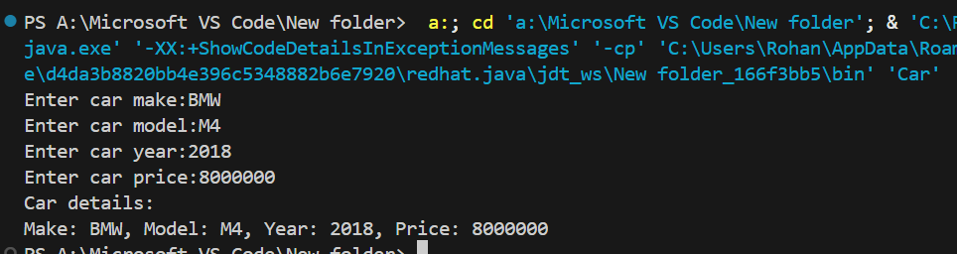**OUTPUT:**

**Assignment 2**

public class Calculator {

    public static int add(int a, int b) {

        return a + b;

    }

    public static int add(int a, int b, int c) {

        return a + b + c;

    }

    public static double add(double a, double b) {

        return a + b;

    }

    public static void main(String[] args) {

        System.out.println("5 + 10 : " + add(5, 10));;

        System.out.println("5 + 10 + 15 : " + add(5, 10, 15));

        System.out.println("5.5 + 10.5 : " + add(5.5, 10.5));

    }

}

**OUTPUT:**

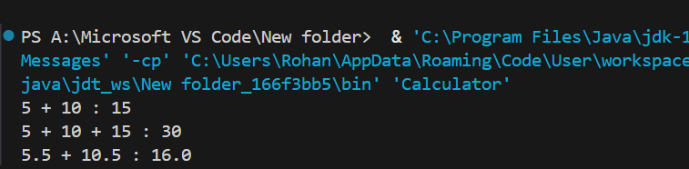

**Assignment 3**

public class Student1 {

    private String name;

    private String department;

    private int age;

    public Student1(String name, int age, String department) {

        this.name = name;

        this.age = age;

        this.department = department;

    }

    public String getName() {

        return name;

    }

    public int getAge() {

        return age;

    }

    public String getDepartment() {

        return department;

    }

    public void setName(String name) {

        this.name = name;

    }

    public void setAge(int age) {

        this.age = age;

    }

    public void setDepartment(String department) {

        this.department = department;

    }

    public static void main(String args[]){

        Student1 student = new Student1("John Doe", 20, "Computer Science");

        System.out.println("Student Name: " + student.getName());

        System.out.println("Student Age: " + student.getAge());

        System.out.println("Department: " + student.getDepartment());

    }

}

**OUTPUT:**

